Lesson 22

**Comparison predicates, aggregate functions in SQL**

Level 1

1. **Display the information from the Shopping_List table (created earlier) about the most expensive and cheapest product. Execute the request using the SELECT command.**

***select min(price) from Shopping_List***

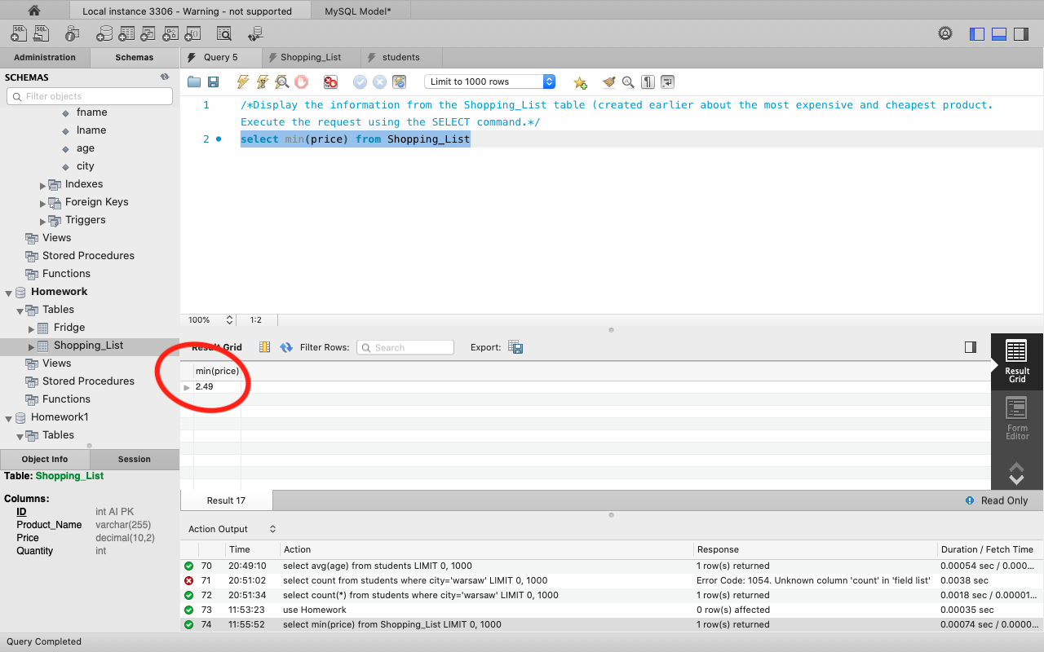

***select max(price) from Shopping_List***

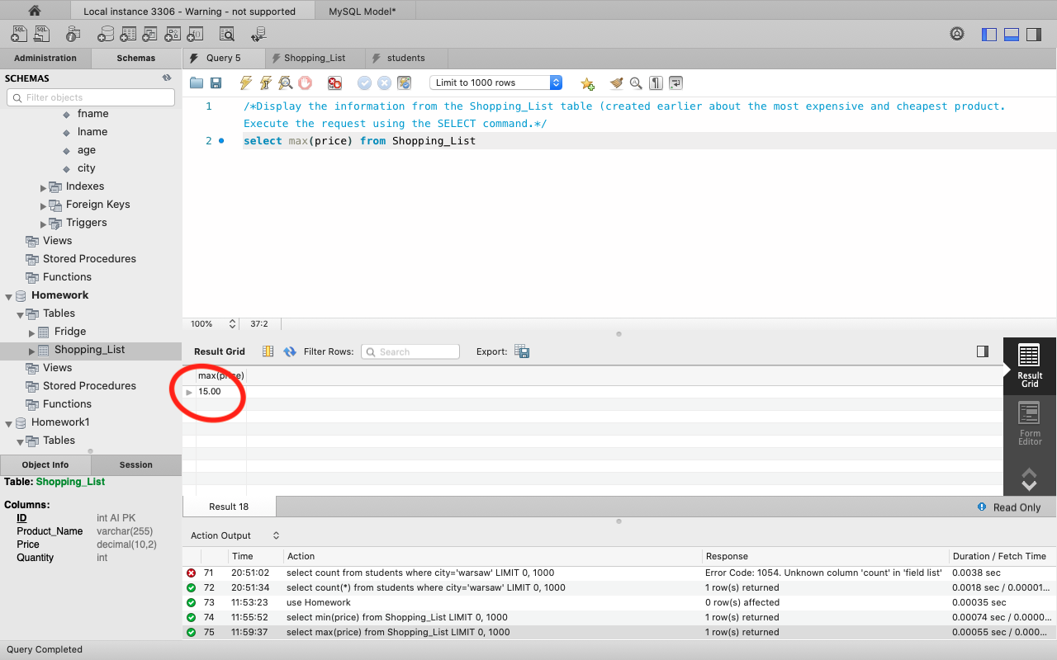

1. **Calculate the average cost of products.**

***select avg(price) from Shopping_List***

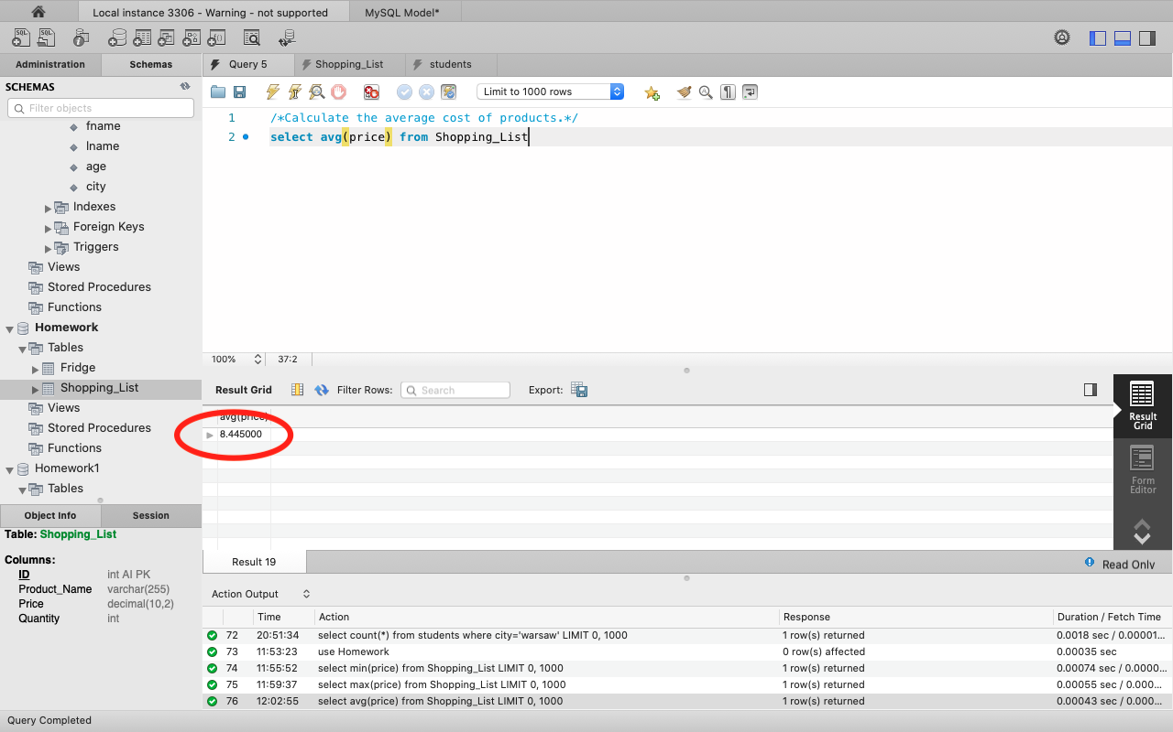

Level 2

**In the Fridge table created for the previous lesson, display information about:**

1. **the number of products in the fridge;**

***select COUNT(*) from Fridge***

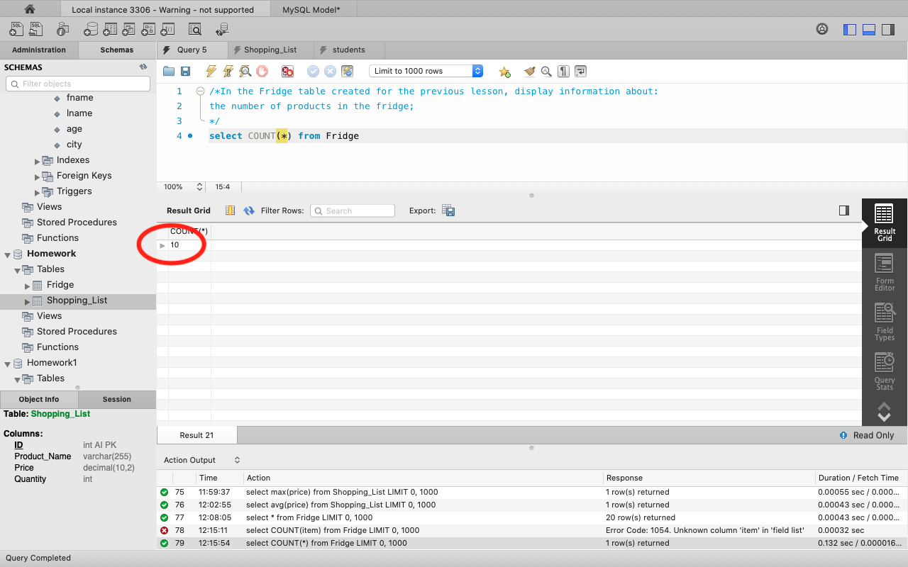

1. **the number of products on the shopping list (from the Shopping_List table);**

***select COUNT(*) from Shopping_list***

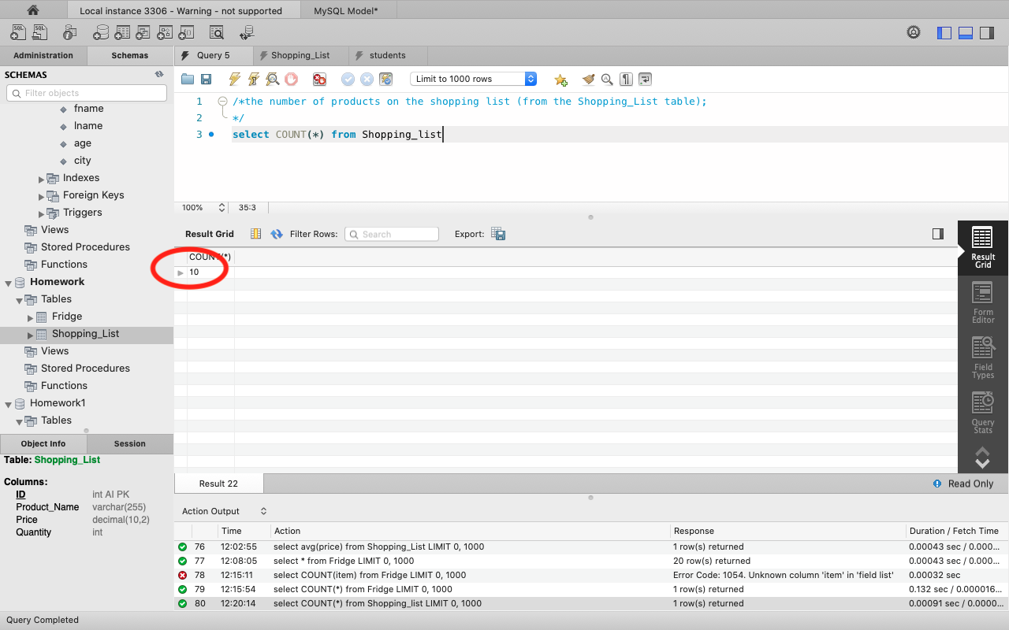

1. **the total number of all products in the Fridge table.**

***select sum(quantity) as total from Fridge***

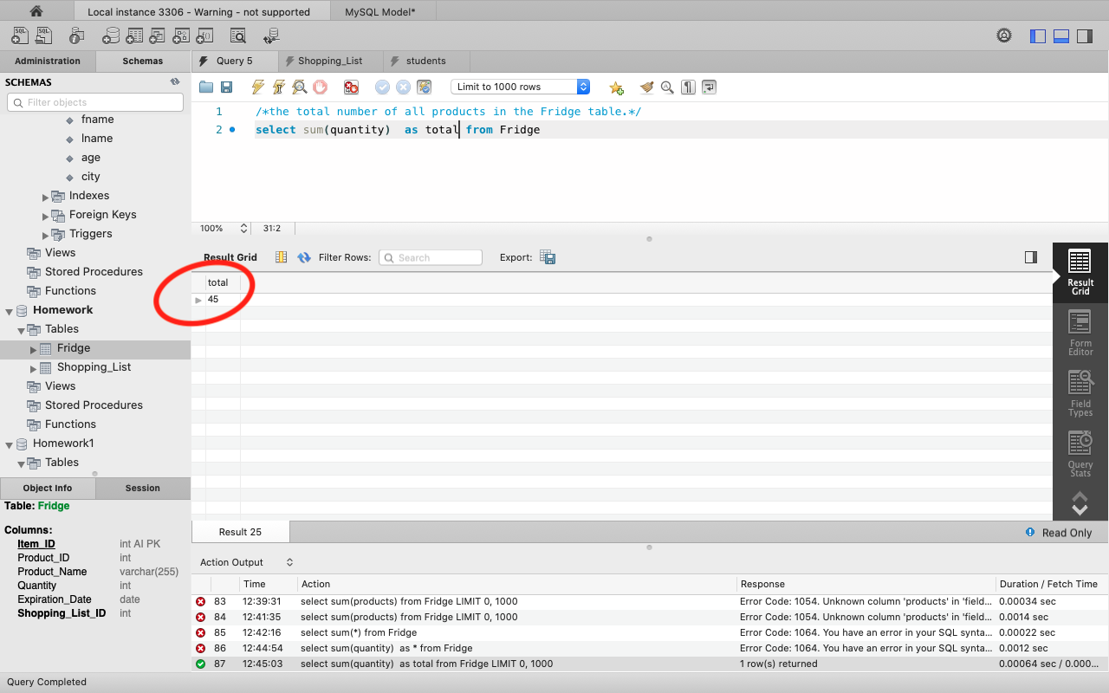

Level 3

**Display information about the number of products and their names (select columns from the Fridge table). Group the results by expiration date.**

***select Expiration_Date, count(*) as Product_Name, group_concat(quantity) from Fridge group by Expiration_Date***

